Experiment No – 7
Title / Aim :- Perform DOM traversal and updates; develop a to-do list app with add, edit, and delete features.

Software/Tools Required :-
- Visual Studio Code (VS Code)
- Google Chrome / Any Web Browser
- HTML
- JavaScript

CODE:-
Index.html
<!DOCTYPE html>
<html lang="en">
<head>
<meta charset="UTF-8">
<meta name="viewport" content="width=device-width, initial-scale=1.0">
<title>Travel Bucket List</title>
<link rel="stylesheet" href="style.css">
</head>
<body>
<div class="container">
<!-- Header -->
<header>
<h1>✈️ My Travel Bucket List</h1>
<p>Plan your dream destinations!</p>
</header>
<!-- Add Destination -->
<section class="add-destination">
<input
type="text"
id="destinationInput"
placeholder="Enter a destination..."
>
<button id="addButton">
+ Add Destination
</button>
</section>
<!-- Destination List -->
<section class="destination-section">
<h2>🌍 My Destinations</h2>
<ul id="destinationList">
<!-- Destinations added dynamically -->
</ul>
</section>
<!-- Counter -->
<div class="counter">
Total Destinations:
<span id="destinationCount">0</span>
</div>
</div>
<script src="script.js"></script>
</body>
</html>

Style.css
* {
box-sizing: border-box;
margin: 0;
padding: 0;
font-family: Arial, sans-serif;
}
body {
background: #a065ec;
min-height: 100vh;
padding: 40px 20px;
color: #66268b;
}
.container {
width: 100%;
max-width: 700px;
margin: auto;
background: white;
border-radius: 18px;
overflow: hidden;
box-shadow: 0 8px 25px rgba(0, 0, 0, 0.12);
}
/* Header */
header {
background: #582258;
color: rgb(243, 241, 241);
padding: 35px;
text-align: center;
}
header h1 {
font-size: 32px;
margin-bottom: 8px;
}
header p {
font-size: 16px;
}
/* Add Destination */
.add-destination {
display: flex;
gap: 10px;
padding: 25px;
border-bottom: 1px solid #e2e8f0;
}
.add-destination input {
flex: 1;
padding: 13px;
border: 1px solid #bae6fd;
border-radius: 8px;
font-size: 16px;
outline: none;
}
.add-destination input:focus {
border-color: #c623db;
}
/* Buttons */
button {
border: none;
border-radius: 8px;
padding: 11px 16px;
cursor: pointer;
font-size: 14px;
color: white;
background: #3d1c3a;
}
button:hover {
opacity: 0.9;
}
/* Destination Section */
.destination-section {
padding: 25px;
}
.destination-section h2 {
margin-bottom: 20px;
}
/* List */
#destinationList {
list-style: none;
}
.destination {
display: flex;
align-items: center;
justify-content: space-between;
background: #f0f9ff;
border: 1px solid #bae6fd;
padding: 15px;
margin-bottom: 12px;
border-radius: 10px;
}
.destination-name {
flex: 1;
font-size: 17px;
}
/* Visited */
.visited {
text-decoration: line-through;
opacity: 0.6;
color: #64748b;
}
/* Action Buttons */
.destination-actions {
display: flex;
gap: 8px;
}
.edit-btn {
background: #f59e0b;
}
.delete-btn {
background: #dc2626;
}
.visited-btn {
background: #16a34a;
}
/* Counter */
.counter {
text-align: center;
padding: 20px;
background: #f0f9ff;
font-size: 16px;
font-weight: bold;
}
#destinationCount {
color: #0284c7;
font-size: 20px;
}
/* Responsive */
@media (max-width: 550px) {
.add-destination {
flex-direction: column;
}
.destination {
flex-direction: column;
align-items: stretch;
gap: 12px;
}
.destination-actions {
width: 100%;
}
.destination-actions button {
flex: 1;
}
}

Script.js
// Get DOM elements
const destinationInput =
document.getElementById("destinationInput");
const addButton =
document.getElementById("addButton");
const destinationList =
document.getElementById("destinationList");
const destinationCount =
document.getElementById("destinationCount");
// Add destination when button is clicked
addButton.addEventListener("click", addDestination);
// Add destination when Enter is pressed
destinationInput.addEventListener("keypress", function (event) {
if (event.key === "Enter") {
addDestination();
}
});
// Add Destination
function addDestination() {
const destinationName =
destinationInput.value.trim();
// Check empty input
if (destinationName === "") {
alert("Please enter a destination!");
return;
}
// Create list item
const destinationItem =
document.createElement("li");
destinationItem.classList.add("destination");
// Create destination name
const nameSpan =
document.createElement("span");
nameSpan.classList.add("destination-name");
nameSpan.textContent =
`📍 ${destinationName}`;
// Create action buttons container
const actions =
document.createElement("div");
actions.classList.add("destination-actions");

// ---------------- EDIT ----------------
const editButton =
document.createElement("button");
editButton.textContent = "Edit";
editButton.classList.add("edit-btn");
editButton.addEventListener("click", function () {
const newDestination =
prompt(
"Edit destination:",
nameSpan.textContent.replace("📍 ", "")
);
if (
newDestination !== null &&
newDestination.trim() !== ""
) {
// Update DOM
nameSpan.textContent =
`📍 ${newDestination.trim()}`;
}
});

// ---------------- DELETE ----------------
const deleteButton =
document.createElement("button");
deleteButton.textContent = "Delete";
deleteButton.classList.add("delete-btn");
deleteButton.addEventListener("click", function () {
const destination =
deleteButton.parentElement.parentElement;
// Remove destination
destination.remove();
// Update count
updateDestinationCount();

});

// ---------------- VISITED ----------------
const visitedButton =
document.createElement("button");
visitedButton.textContent = "Visited";
visitedButton.classList.add("visited-btn");
visitedButton.addEventListener("click", function () {
// Toggle visited style
nameSpan.classList.toggle("visited");
// Change button text
if (
nameSpan.classList.contains("visited")
) {
visitedButton.textContent =
"Visited ✓";
} else {
visitedButton.textContent =
"Visited";
}
});
// Append buttons
actions.appendChild(editButton);
actions.appendChild(deleteButton);
actions.appendChild(visitedButton);
// Append destination and actions
destinationItem.appendChild(nameSpan);
destinationItem.appendChild(actions);
// Add to DOM
destinationList.appendChild(destinationItem);
// Clear input
destinationInput.value = "";
// Update count
updateDestinationCount();
}
// Update Destination Counter
function updateDestinationCount() {
// DOM traversal using children
const total =
destinationList.children.length;
destinationCount.textContent =
total;
}

Output

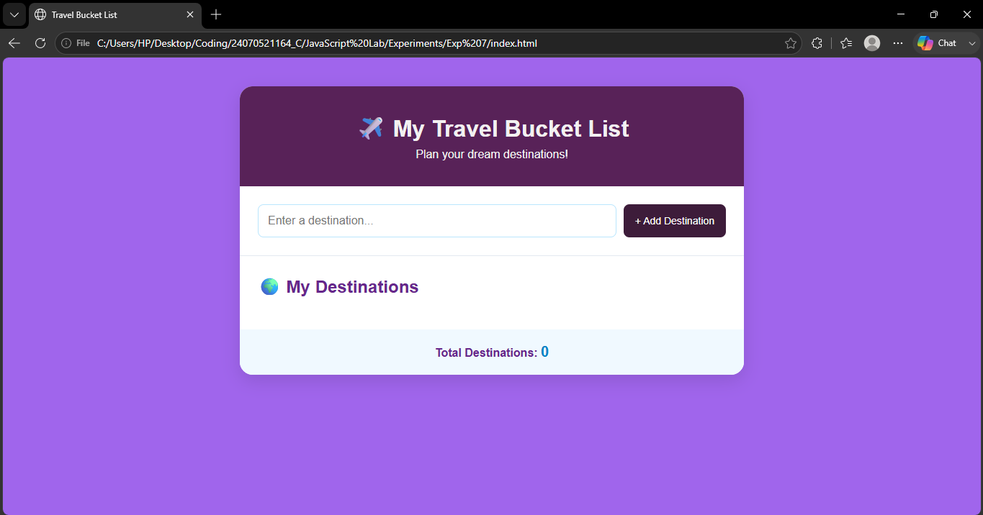

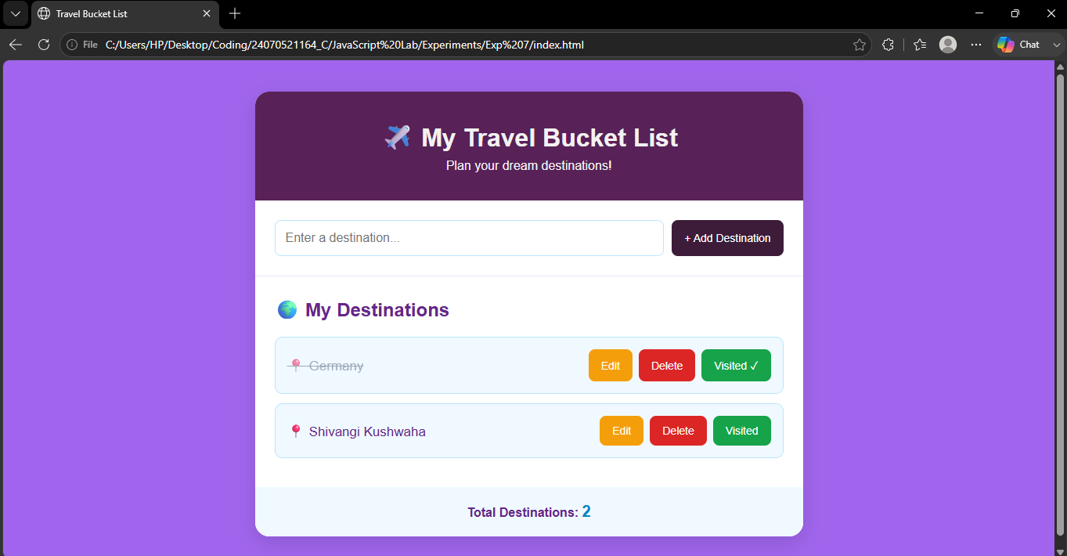

Result / Conclusion :-
The Travel Bucket List application was successfully developed using HTML, CSS, and JavaScript. The application allows users to dynamically add, edit, and delete travel destinations. DOM traversal was demonstrated using parentElement, while DOM updates were performed using methods such as createElement(), appendChild(), textContent, and remove(). The application also allows destinations to be marked as visited using classList.toggle(). Thus, the experiment provided practical understanding of DOM traversal, dynamic updates, and event handling in JavaScript.

